**Worksheet-2**

**Student Name:- Pushpraj Roy UID:- 20BCS9866**

**Branch:- BE- CSE Section/Group:- WM_617 “A”**

**Subjetct Code:- 20CSP-321 Semester:- 5th**

**Subject Name:- PBLJ Lab**

1. **Aim/ Overview of the practical:-**

Design and implement a simple inventory control system for a small video rental store

1. **Task To be done :-**

Make a simple inventory control system for a small video rental store.

1. **S/W Requirements:-**

* JDK
* VS Code

1. **Algorithm/Flowchart :-**

* Start
* Make a class with name Video. In this class make variable related to video.
* Make a class with name Video Store. In this class functions are made for add video, rent video, return video.
* Make a main class with name Video Store Launcher. In this class we call all the function with object of the class.
* End.

1. **Code :-**
2. **Code of Video class :**

import java.util.Scanner;

public class Video {

    public String title;

    public boolean checked = true;

    int avgrating;

    public boolean checked()

    {

        return checked;

    }

    public void rent() {

        checked = false;

    }

    public void returned()

    {

        checked = true;

        System.out.println("Video is returned ");

    }

    public int getRating()

    {

        if (avgrating > 0)

        {

            return avgrating;

        } else {

            System.out.println(" Rating is not available");

            return 0;

        }

    }

}

1. **Code of Video Store class**

import java.util.Scanner;

public class VideoStore extends Video {

    Video v[] = new Video[10];

    static int i = 0;

    void addVideo(String title)

    {

        v[i] = new Video();

        this.title = title;

        v[i].title = title;

        i++;

        System.out.println("Video Added Successfully");

    }

    void checkOut(String title)

    {

        for (int k = 0; k < i; k++)

        {

            if (v[k].title.equalsIgnoreCase(title)) {

                if (v[k].checked()) {

                    v[k].rent();

                    System.out.println("Video is rented");

                }

                else {

                    System.out.println("Sorry Video not available");

                }

            }

        }

    }

    void returnVideo(String title) {

        if (i == 0)

        {

            System.out.println("You have no video to return");

        }

        for (int k = 0; k < i; k++)

        {

            if (v[k].title.equalsIgnoreCase(title)) {

                v[k].checked = true;

            }

        }

    }

    public void receiveRating()

    {

        if (i == 0) {

            System.out.println("No Video inInventory");

        }

        else {

            for (int k = 0; k < i; k++)

            {

                System.out.println("Enter the rating for movie" + v[k].title);

                Scanner ob = new Scanner(System.in);

                v[k].avgrating = ob.nextInt();

            }

        }

    }

    public void listInventory() {

        if (i == 0)

        {

            System.out.println("No Video in Inventory");

        }

        else

        {

            for (int k = 0; k < i; k++)

            {

                System.out.println(k + 1 + ". " + v[k].title + " " + "Rating " +

                               v[k].avgrating + " Availability" + v[k].checked());

            }

        }

    }

}

1. **Code of Video Store Launcher class**

import java.util.Scanner;

public class VideoStoreLauncher {

  public static void main(String[] args) {

    VideoStore vs = new VideoStore();

    int ch, uCh, aCh, vno;

    String title, choice;

    do {

      System.out.println("=========Menu=========");

      System.out.println("1. Login as User");

      System.out.println("2. Login as Admin");

      System.out.println("Enter Your Choice");

      Scanner s = new Scanner(System.in);

      ch = s.nextInt();

      do {

        switch (ch)

        {

          case 1:

            System.out.println("1. List Inventory");

            System.out.println("2. Rent Video");

            System.out.println("3. Enter the rating of Video");

            System.out.println("4. Return Video");

            uCh = s.nextInt();

            if (uCh == 1)

            {

              vs.listInventory();

            }

            else if (uCh == 2)

            {

              vs.listInventory();

              System.out.println("Enter the video Name you want");

              title = s.next();

              vs.checkOut(title);

            }

            else if (uCh == 3) {

              vs.receiveRating();

            }

            else if (uCh == 4)

            {

              vs.rent();

            }

            else

            {

              System.out.println("No such Option is available");

            }

            break;

          case 2:

            System.out.println("1. List Inventory");

            System.out.println("2. Add Video");

            aCh = s.nextInt();

            if (aCh == 1)

            {

              vs.listInventory();

            }

            if (aCh == 2)

            {

              System.out.println("Enter the name of Video");

              title = s.next();

              vs.addVideo(title);

            }

            break;

          default:

            System.out.println("Sorry Wrong Choice");

        }

        System.out.println("Do you want to repeat yes/no");

        choice = s.next();

      } while (choice.equalsIgnoreCase("yes"));

      System.out.println("Want to Return to main Menu yes/no");

      choice = s.next();

    } while (choice.equalsIgnoreCase("yes"));

  }

}

1. **Result/Output/Writing Summary:-**

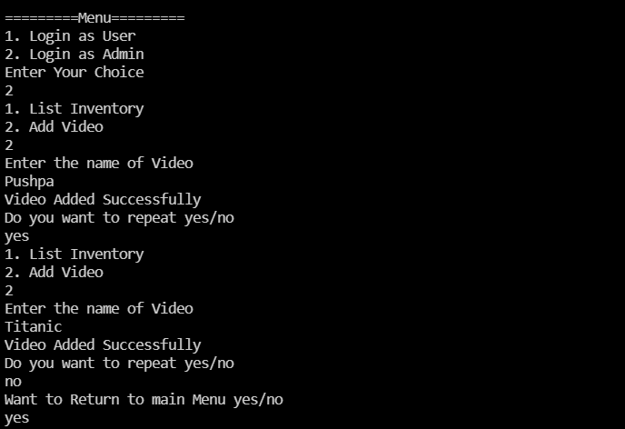

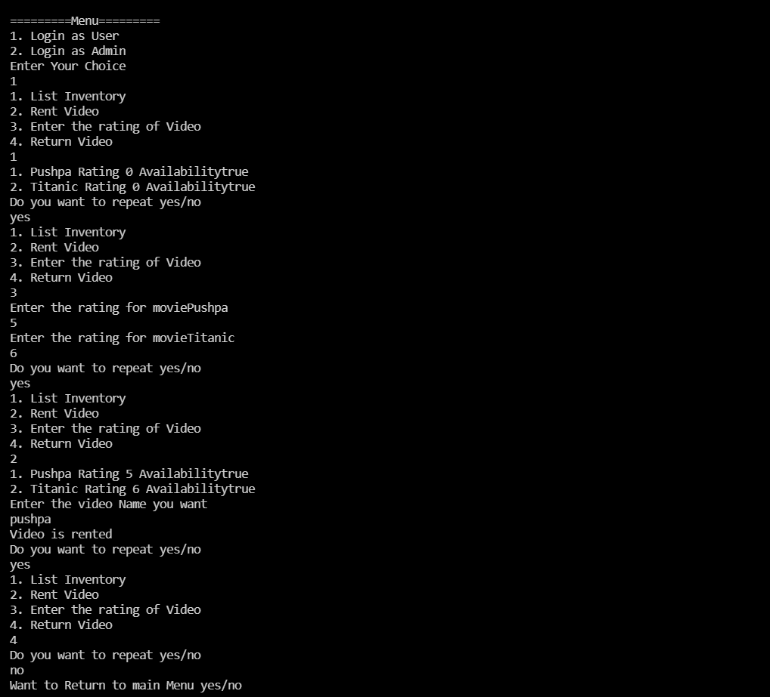

1. **Learning Outcomes (What I have learnt) :-**

* Identify situations where computational methods would be useful.
* Approach the programming tasks using techniques learnt and write pseudo-code.
* Choose the right data representation formats based on the requirements of the problem.
* Use the comparisons and limitations of the various programming constructs and choose the right one for the task.